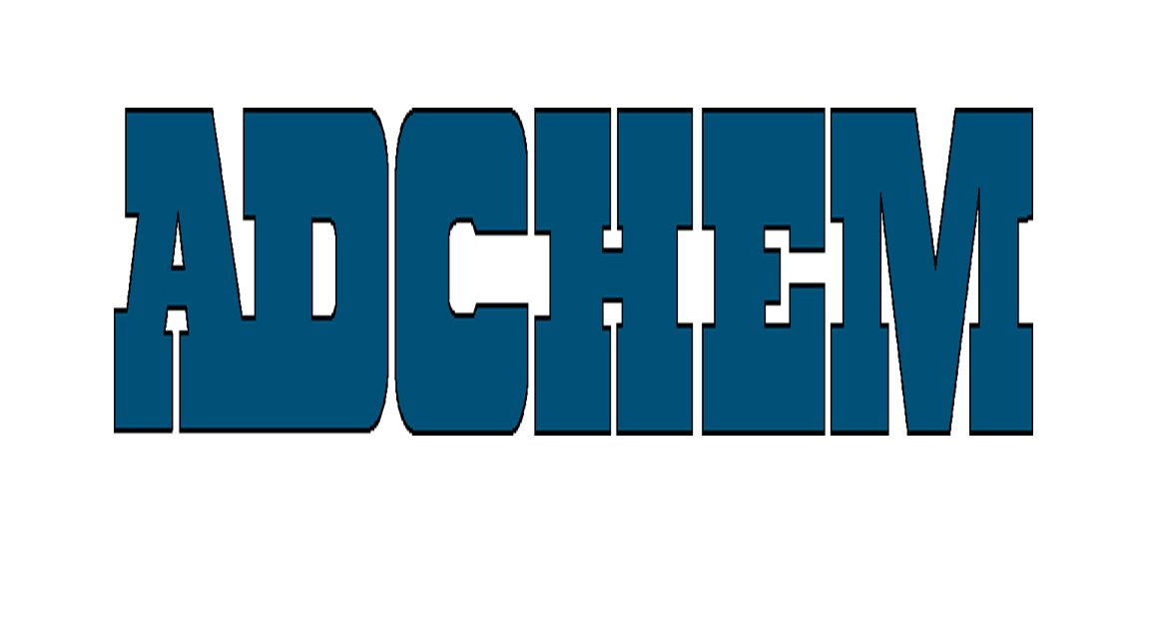
the adhesive tape engineersTM

For Immediate Release

Adchem’s New 650 Family of LSE Bonding Tapes Demonstrates Excellent Foam Bonding Characteristics.

Adchem Corporation, a major supplier of adhesive tapes for the automotive and industrial markets, has demonstrated that its new 650 family of adhesive tapes designed for Low Surface Energy substrate bonding, also demonstrates excellent foam bonding characteristics which is an added benefit. Recent testing on Armacell’s ECF-400 Foam shows destructive foam bonding characteristics, an important feature when a foam gasket requires good adhesion to a low surface energy component.
Adchem’s double-coated, single-coated and unsupported adhesive tape systems coupled with its advanced engineering capabilities enables Adchem to develop high performance adhesive tapes for the most demanding applications.

About Adchem Corporation
Adchem, an ISO 9001 certified and A2LA accredited company, manufactures pressure-sensitive adhesive tape systems, including double-coated papers, films, tissues, foams and fabrics; transfer tapes; one-side coated products and other custom-coated specialty products. Our 100% solids adhesives, solvent and water based acrylics and rubber adhesives are used in a variety of industries, including automotive, construction, electronics, graphic arts, medical, and general industrial tape applications.

About Armacell
Armacell is a global innovator and proven leader in cellular foam technologies. Armacell produces elastomeric foam insulation materials and specialized foams for a variety of industries, including general industrial and automotive. Armacell offers innovative product solutions for sound absorption and vibration dampening applications with Ensolite®, and Monarch® products, many different protective padding niches with EnsoLine® products, and shock-absorbing padding for the sport/leisure, synthetic turf and antifatigue mat sectors with ArmaSport® products. The North America headquarters for Armacell LLC is located in Mebane, NC. For more information on Armacell and its products, visit the Technical Foam section of our web site at www.armacell.us

For additional information and samples, please contact Mr. Walter Polifka at Adchem Corporation, 1852 Old Country Road, Riverhead, NY 11901 Phone: (631) 727-6000 Fax: (631) 727-6010 or our website at www.adchem.com.

