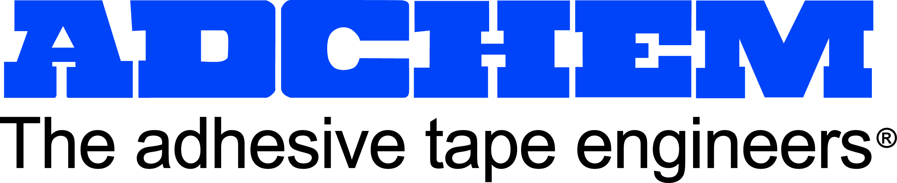

For Immediate Release:

Contact:
Joseph Pufahl
Adchem Corporation
631-727-6000
631-727-0164
jpufahl@adchem.com
www.adchem.com
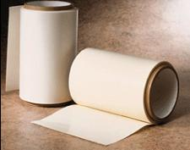

Adchem Creates New 650 LSE Tape Systems

Adchem Corporation has engineered a new family of acrylic tape products to bond to Low Surface Energy (LSE) materials increasingly used in the automotive, electronics, and transportation markets. The 650 Series of products has been engineered specifically for LSE high performance, durable-bonding applications and are available in double-sided PET, double-coated tissue, and an array of unsupported transfer tape products.

Adchem has conducted extensive bonding studies using the 650 products demonstrating exceptional bond to a wide variety of open and closed-cell foams and low surface energy substrates such as TPO’s, polypropylene, polyethylene, as well as powder-coated paint surfaces. The studies are available at www.adchem.com and include automotive grade LSE materials.

Adchem’s double-sided, single-coated and unsupported adhesive tape systems coupled with its advanced engineering capabilities enable the nearly 50 year old company to guide engineers to over 200 products and custom development for the most demanding industrial and consumer applications.

About Adchem Corporation
Adchem is ISO 9001 certified with extensive A2LA laboratory process accreditations. The nearly 50 year old company engineers and manufactures pressure-sensitive adhesive tape systems, including double-sided papers, films, tissues, foams and fabrics; transfer tapes; one-side coated products and other custom-coated specialty products. 100% solids adhesives, solvent and water based acrylics and rubber adhesives are used in a variety of industries, including automotive, construction, electronics, graphic arts, medical, transportation and general industrial tape applications. Adchem recently announced its certification under the newly established Responsible Tape Manufacturer (RTM) program of the Pressure Sensitive Tape Council (PSTC).
For additional information and samples, please contact Adchem Corporation, 1852 Old Country Road, Riverhead, NY 11901 Phone: (631) 727-6000 Fax: (631) 727-6010 or our website at www.adchem.com .

