the adhesive tape engineersTM

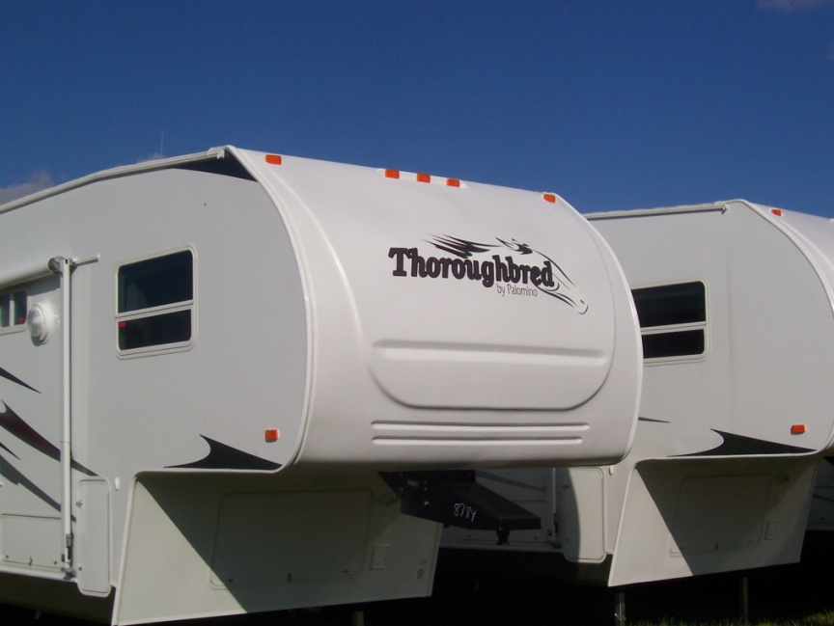

For Immediate Release

Adchem Announces Adhesive Tapes

for

ExtremeTM TPO Materials from Spartech

Adchem Corporation, a major supplier of adhesive tapes for the automotive and industrial markets, has completed a bonding study involving ExtremeTM TPO plastic materials from Spartech. The study of 14 adhesive tapes bonded to three popular grades of Spartech TPO’s includes Adchem’s acrylic and rubber based doubled coated and transfer tapes as well as the new 653 transfer tape engineered for foam and Low Surface Energy substrate bonding. This information is available on Adchem’s web site shown below. Applications for TPO materials include body components for recreational vehicles

Adchem’s double-coated, single-coated and unsupported adhesive tape systems coupled with its advanced engineering capabilities enables Adchem to develop high performance adhesive tapes for the most demanding applications.

About Adchem Corporation
Adchem, an ISO 9001 certified and A2LA accredited company, manufactures pressure-sensitive adhesive tape systems, including double-coated papers, films, tissues, foams and fabrics; transfer tapes; one-side coated products and other custom-coated specialty products. Our 100% solids adhesives, solvent and water based acrylics and rubber adhesives are used in a variety of industries, including automotive, construction, electronics, graphic arts, medical, and general industrial tape applications.

About Spartech
Spartech Corporation is a leading producer of plastic products including polymeric compounds, concentrates, custom extruded sheet and rollstock products and packaging technologies for a wide spectrum of customers. The Company's three business segments, which operate facilities in the United States, Mexico, Canada, and France, annually process approximately one billion pounds of plastic resins, specialty plastic alloys, and color and specialty compounds.

For additional information and samples, please contact Chris Pufahl at Adchem Corporation, 1852 Old Country Road, Riverhead, NY 11901 Phone: (631) 727-6000 Fax: (631) 727-6010 or our website at www.adchem.com.

